6.3 oxidising agent
Name: ____________________ Class: ____________________ Due date: 10.19
1. Copper(II) oxide reacts with hydrogen.
CuO + H₂ → Cu + H₂O
Which row is correct? （ ）
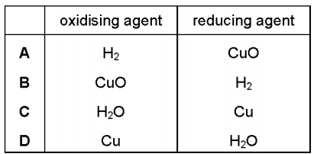

2. In which equation is the underlined substance acting as a reducing agent? （ ）
A 3CO + Fe₂O₃ → 2Fe + 3CO₂
B CO₂ + C → 2CO
C CuO + H₂ → Cu + H₂O
D CaO + H₂O → Ca(OH)₂

3. The thermite reaction can be used to produce iron from iron(III) oxide.
The equation for the reaction is shown.
2Al + Fe₂O₃ → 2Fe + Al₂O₃
Which statements about this reaction are correct? （ ）
1 Aluminium is the oxidising agent.
2 Aluminium is less reactive than iron.
3 Electrons are transferred from aluminium to iron.
4 The iron in the iron(III) oxide is reduced.
A 1 and 3 B 1 and 4 C 2 and 3 D 3 and 4

4. The equation for the reaction between iron(II) sulfate and bromine is shown.
6FeSO₄ + 3Br₂ → 2Fe₂(SO₄)₃ + 2FeBr₃
Which row identifies the oxidising agent and the reducing agent? （ ）
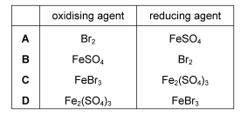

5. The reaction between chlorine and bromide ions is a redox reaction.
Cl₂ + 2Br⁻ → 2Cl⁻ + Br₂
What is the change in oxidation state of the reducing agent in this reaction? （ ）
A –2 to 0 B –1 to 0 C 0 to –1 D 0 to +1

6. In the blast furnace, iron is formed when iron(III) oxide reacts with carbon monoxide in a redox reaction.
Fe₂O₃ + 3CO → 2Fe + 3CO₂
Which substance is the oxidising agent and which substance is the reducing agent? （ ）
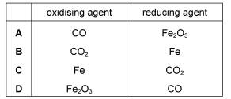

7. Equation for the reaction between zinc and aqueous copper(II) sulfate is shown.
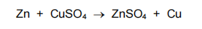
Which statement is correct? （ ）
A The oxidation state of the oxidising agent has changed from 0 to +2.
B The oxidation state of the reducing agent has changed from 0 to +2.
C The oxidation state of the reducing agent has changed from +2 to 0.
D This is not a redox reaction. The solution changes from colourless to blue.

8. The equation for a redox reaction is shown.
2Fe³⁺ + Zn → 2Fe²⁺ + Zn²⁺
Which statements are correct? （ ）
1 Fe³⁺ is reduced to form Fe²⁺.
2 Zn oxidises the Fe³⁺ ions.
3 Fe³⁺ is an oxidising agent.
A 1, 2 and 3 B 1 and 2 only C 1 and 3 only D 2 and 3 only

9. Copper metal donates electrons to silver ions.
Zinc metal donates electrons to copper ions.
What is the strongest reducing agent? （ ）
A copper ions B copper metal C silver ions D zinc metal

10. When magnesium is added to aqueous copper(II) sulfate a reaction occurs.
The ionic equation for the reaction is shown.
Mg + Cu²⁺ → Mg²⁺ + Cu
(i) Explain why this is a redox reaction.
(ii) Identify the oxidising agent in this reaction. Give a reason for your answer.
(iii) A redox reaction occurs when magnesium is heated with iron(III) oxide.
Write a chemical equation for the reaction between magnesium and iron(III) oxide.
11. Calcium reacts with nitrogen to form the ionic compound calcium nitride,
Ca₃N₂.The reaction between calcium and nitrogen to form calcium nitride is a redox reaction.In terms of electron transfer, explain why calcium is the reducing agent.

12. Displacement reactions occur between metals and metal ions.
Displacement reactions can be used to determine the order of reactivity of metals such as lead (Pb), nickel (Ni), and silver (Ag).
The ionic equation for a displacement reaction is shown.
Ni(s) + Pb²⁺(aq) → Pb(s) + Ni²⁺(aq)
The ionic half - equations for this reaction are shown.
Ni(s) → Ni²⁺(aq) + 2e⁻
Pb²⁺(aq) + 2e⁻ → Pb(s)
The ionic half - equations show that electrons are donated by nickel atoms and accepted by lead ions.
13. (i) Identify the reducing agent in the displacement reaction.
Give a reason for your answer.
reducing agent
reason
(ii) What is the general term given to the type of reaction in which electrons are transferred from one species to another?
(b) The ionic equation for another displacement reaction is shown.
Pb(s) + 2Ag⁺(aq) → 2Ag(s) + Pb²⁺(aq)
Write the two ionic half - equations for this reaction.
1
2
14. Oxidation numbers in a formula add up to zero.
a Give the oxidation state of the underlined atom in each formula below:
i aluminium oxide, Al₂O₃
ii ammonia, NH₃
iii H₂CO₃ carbonic acid
iv phosphorus trichloride, PCl₃
v copper(I) chloride, CuCl
vi copper(II) chloride, CuCl₂

